Created by: John Ditter
Last Updated: 3/25/2020
How to Open Zoom on School Computer (or open with web browser)
Step 1: Enter “zoom” into web browser (preferably Google Chrome) or for a direct link type “zoom.us”
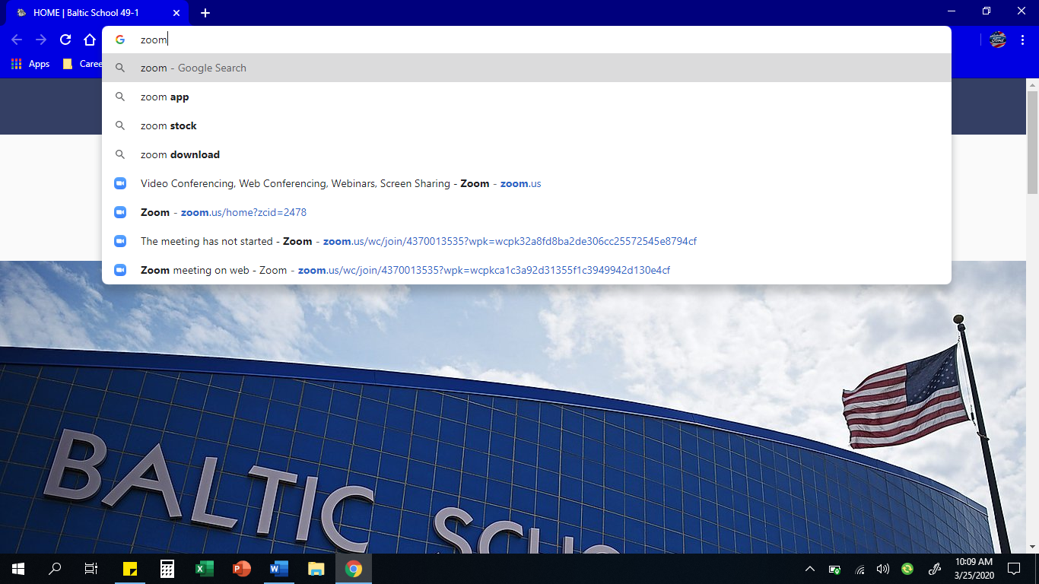

Step 2: Click on the 1st link on the Google search (if entered “zoom.us” and webpage works, skip to step 3)
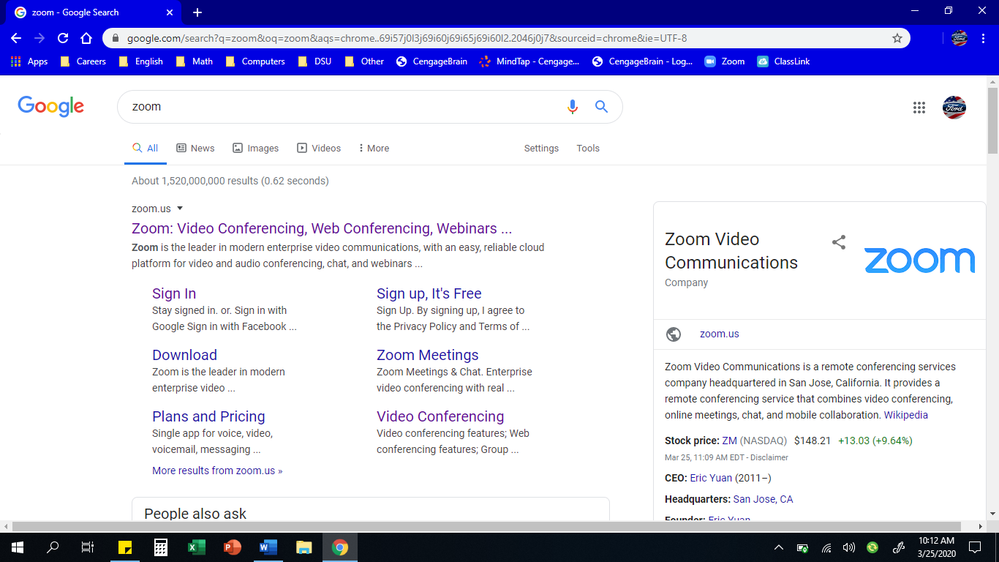

Step 3: Click Join a Meeting link on top right of the screen
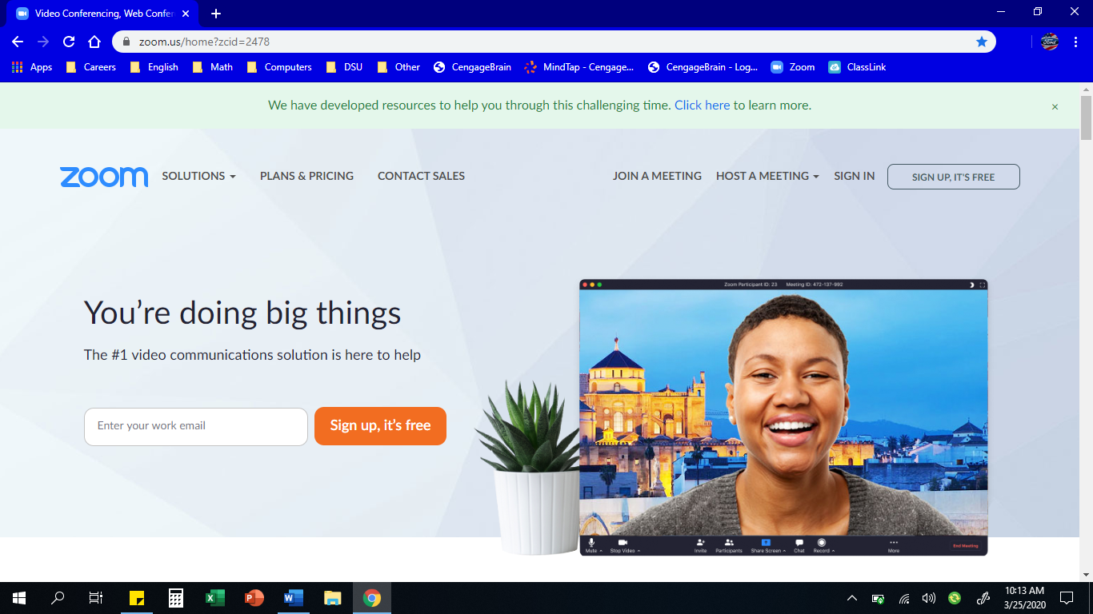

Step 4: Enter in Meeting ID number (it should look like ###-###-####, like a phone number). Then press the Join button.
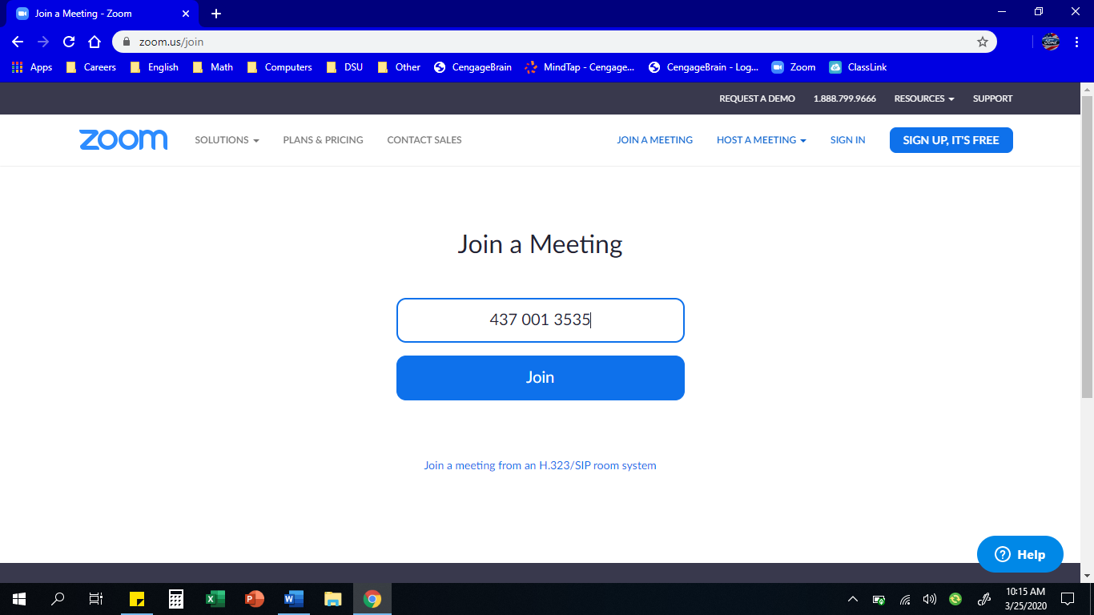

Step 5: The screen will look like the screenshot below. If it is your 1st time opening Zoom, it will try to download a file. Ignore the downloaded file and wait for screen to look like screenshot in Step 6.
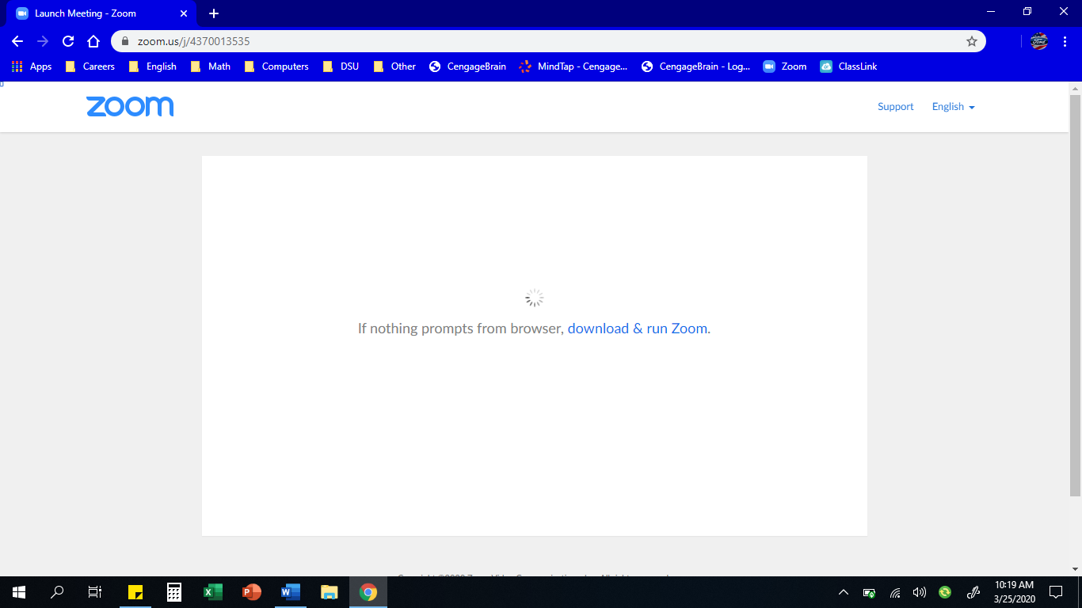

Step 6: If your screen looks like the screenshot below, skip to Step 7. If your screen doesn’t look like the screenshot below, Refresh the webpage. If that still doesn’t work, try Restarting your computer.
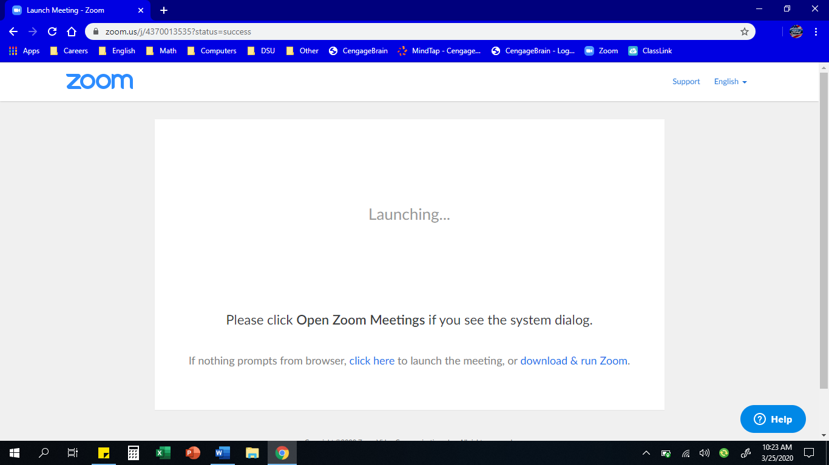

Step 7: Press the Click Here link.
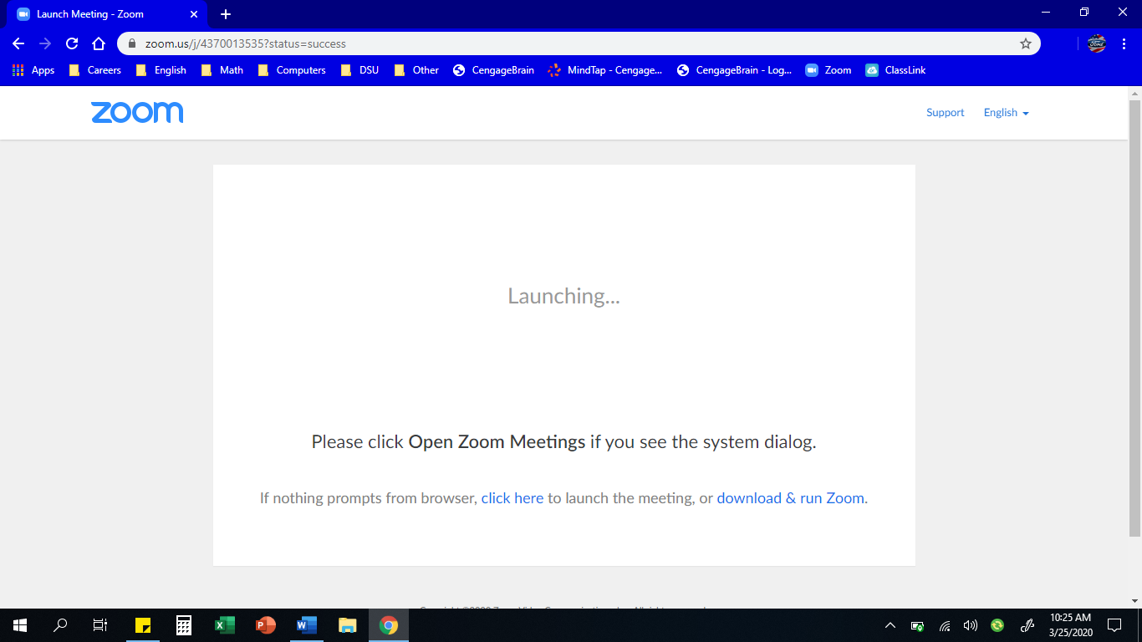

Step 8: From completing Step 7, there should be some words that pop up below. Press the Join From Your Browser link.
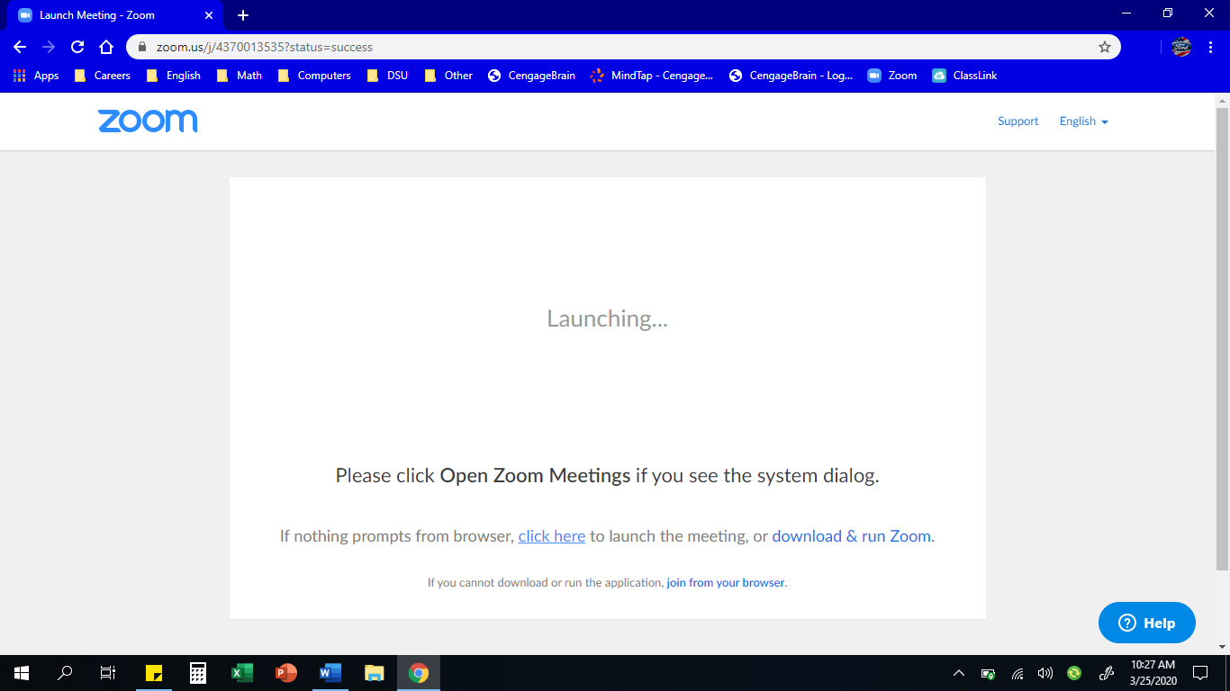

Step 9: Enter in your name. Then press the Join button.
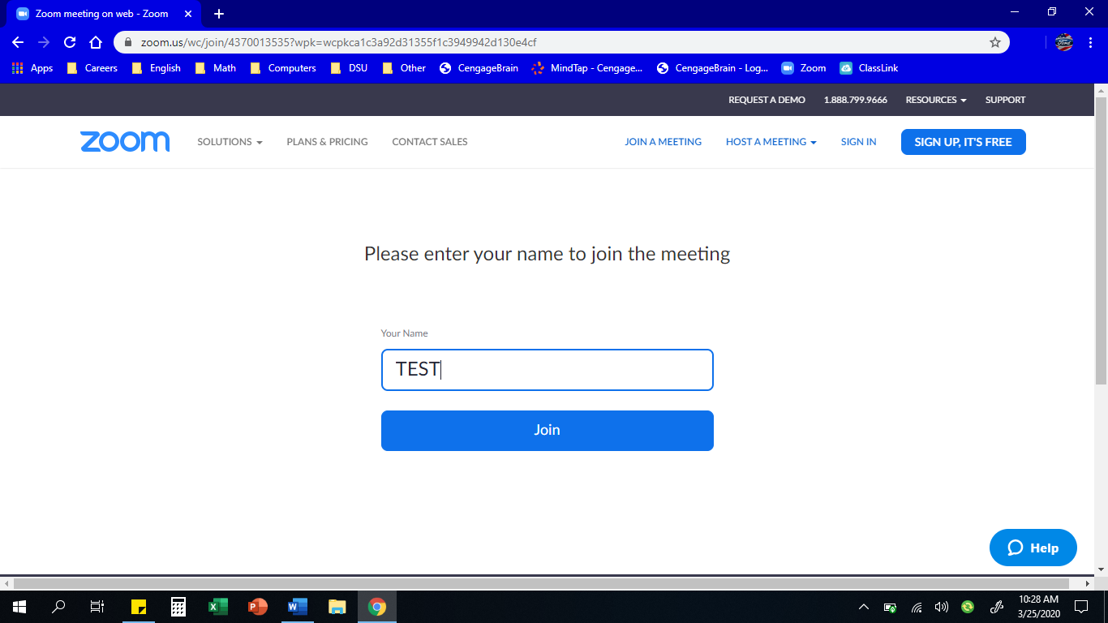

Step 10: Your screen should look like the screenshot below. Click the Join Audio by Computer button.
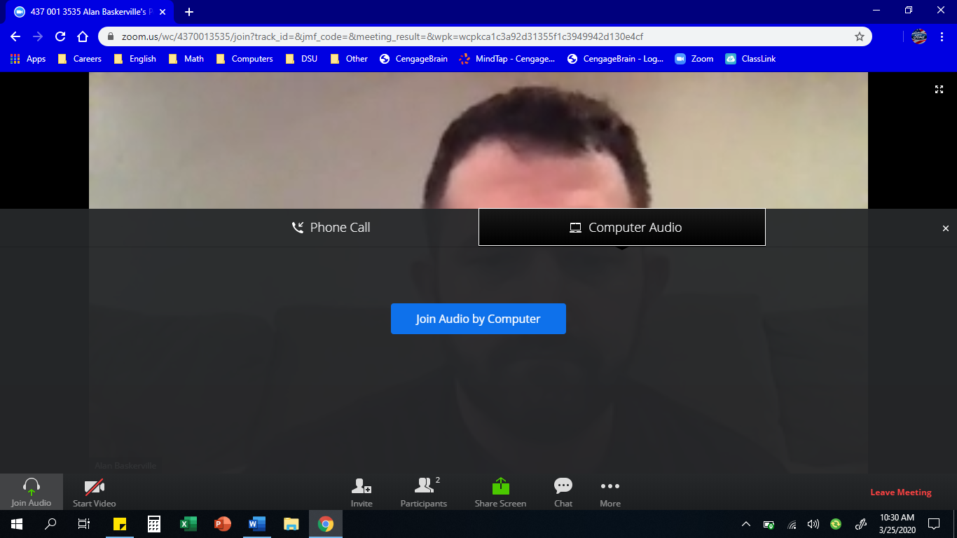

Step 11: By this step, you should be able to see your teacher or your teacher’s computer screen. Below are features you might use in Zoom.

Audio/Microphone: You can mute and unmute yourself by clicking the microphone icon on bottom left. If you have multiple audio devices (ex. Multiple speakers, or a plug-in microphone), you can choose which one to use by using pressing the arrow button and selecting the name of the device.
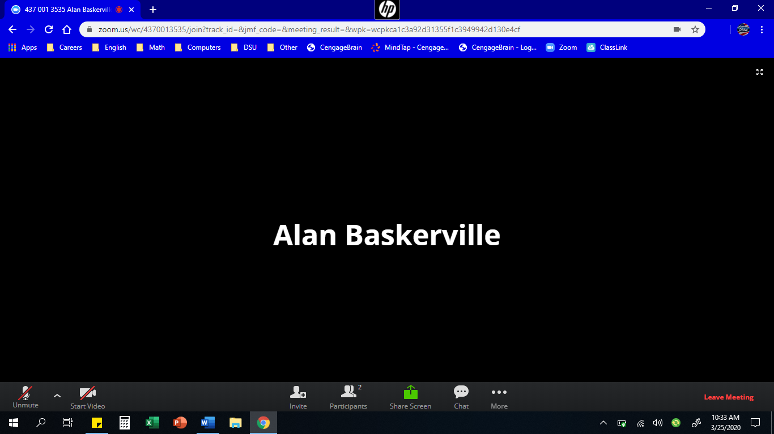

Camera (if computer has one): You can turn on and off your camera by pressing the camera icon button. If your computer has multiple cameras, you can press the arrow button and select the name of the camera.

Parcipants: To see who is currently in the meeting, press the Parcipants button. It show pop up a screen with a list of names.

Screen Sharing: To share your computer screen with the meeting, press the Screen Share button. This feature will only work if the host allows it. If allowed, a screen will show, letting you choose which window or screen you want to share. This feature will show a live feed of any window or screen you choose.

Chat: To talk with members of the meeting without audio, press the Chat button. It will pop up a screen that shows a messaging format. You can choose whether to send a message to Everyone or to a certain member.

Leave Meeting: To leave the meeting, press the Leave Meeting button.

